LECTURE: Using NetBeans IDE

Purpose: Start to work with the IDE we will use for developing Java projects

Resources: Online NetBeans Help

Intro:

There are many different Third Party tools that can be used to develop a Java program. In fact, we could simply use notepad to create .java files

We could use JSDK and command line prompt to compile and run our programs

However, there are many other software packages that make this effort much easier

We will use NetBeans

Other tools are BlueJ, Jcreator, Eclipse

First Things First:

If you do not already have it, Create a LINK on your Desktop to the JAVA DOC
The Java Doc is on EACH computer in the following folder:

DOCUMENTS AND SETTINGS/ALL USERS/DOCUMENTS/

This document will be used to work with Java Classes

The Basics:

Before you write a project you need to CREATE A FOLDER IN YOUR AREA ON THE FILE SERVER

To run your programs successfully, YOU must be logged on to the server with YOUR student account

Save through the My Documents folder on the workstations Desktop

MAKE SURE YOU ARE WORKING THROUGH DOCUMENTS and SETTINGS / MY DOCUMENTS

Add a folder called: HelloWorld

The work you do while logged on is SYNCHRONIZED and saved on the FileServer when you LOG OUT, so Make sure you LOG OUT at the end of each class or your work WILL BE LOST !!!!!

Run Net Beans:

Run Net Beans

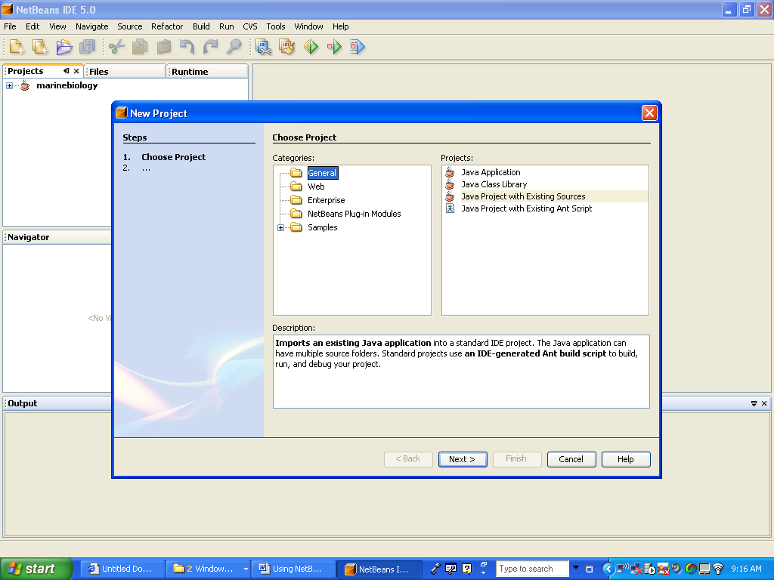

Create a new Java Application Project
FILE NEW PROJECT

You have TWO choices:

Select General … Java Application to create a new project that does not use any pre existing
Classes or source files

Select General … Java Project with Existing Sources if you plan on using pre existing
JAR, class or source files.

The “MBS INSTALLATION DOCUMENT.DOC” that details the procedure
For using this option.

For now, select the first choice.

Name the project helloworld and select the options as follows:

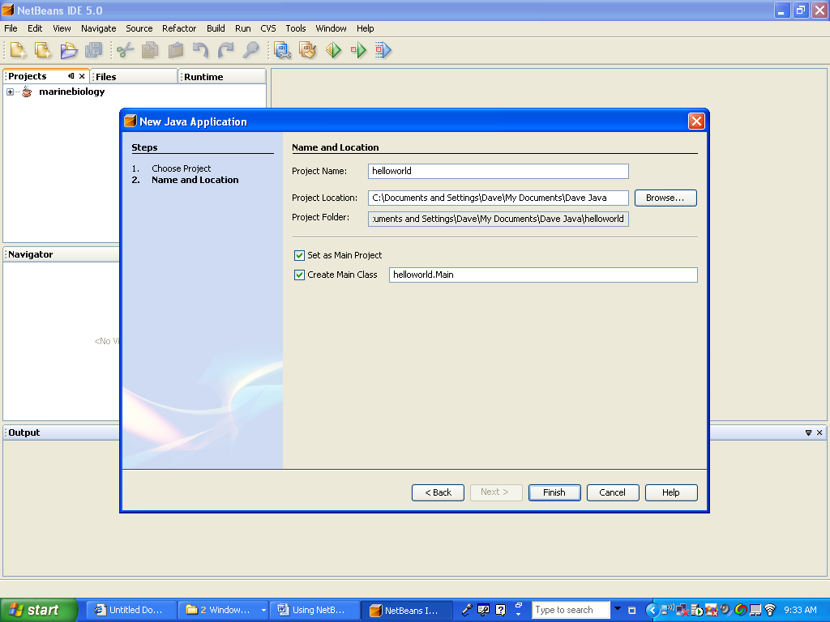

Select FINISH

You will get the following main project. Code the following in the SPVM and then run it by clicking
On the run Icon:

System.out.println("hello world");

The result is on the bottom of the following screen shot:
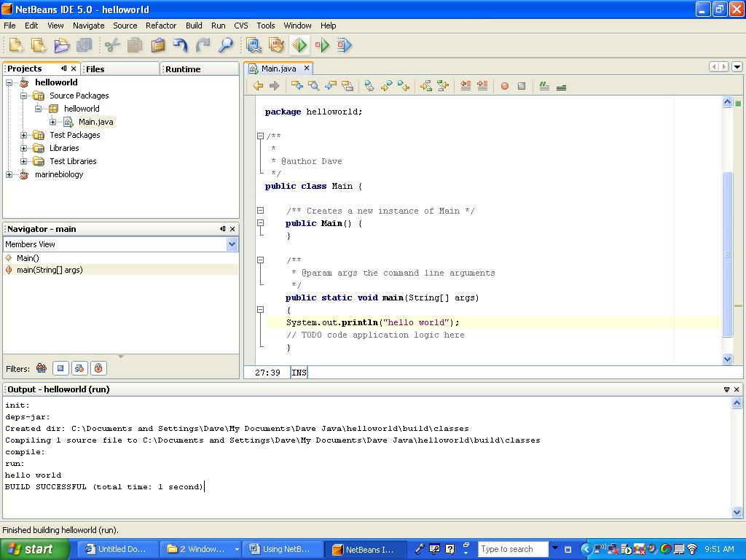

Look at Resulting Files:

In the Source Packages, you have the helloworld folder. In this folder you have the main file MAIN.JAVA

This is the file where the SPVM will be executed.

In the Libraries package, you have the JDK 1.5 PLUS any other packages you require for this program.

When you are done working, close your project and close NetBeans. Then BACKUP your project by COPYING the entire project folder to your smart drive.

If you work on the project at home, save the whole folder back onto the smart drive and then COPY the entire folder onto your student account OVERLAYING the previous project.

Debugger:

Have some fun by changing your source code and then RECOMPILE

See if you can identify the errors

Use the debugger to set a breakpoint

